Local Innovation Partnerships Fund (LIPF)

Applicant Briefing: What Projects We Are Looking For

Purpose of the LIPF
The Local Innovation Partnerships Fund (LIPF) has been launched by UKRI to strengthen regional innovation ecosystems, accelerate near-to-market research and development, and support the growth of high-value industrial clusters across the UK.
South West Wales has been identified in the UK Industrial Strategy, the Regional Economic Delivery Plan (REDP) and the UK Critical Minerals Strategy as a region with nationally significant assets in clean energy, advanced manufacturing, recycling, materials recovery and industrial transition. With major energy and port infrastructure, deep foundation industries, strong university and innovation capabilities, and a growing clean-energy supply chain, the region is well placed to drive UK-wide industrial resilience and low-carbon economic growth.
To build on this strategic position, the four local authorities of South West Wales are preparing a regional LIPF bid themed Industrial Resilience: Material and Energy Security. The bid will assemble a portfolio of high-quality, near-to-market innovation projects that strengthen supply chains, accelerate low-carbon industrial transformation, and increase private sector investment in the region. This Expression of Interest (EOI) process is designed to gather potential anchor projects and wider programme ideas from industry, academia, local authorities and third sector partners. Submissions will help shape the regional portfolio and ensure that proposed activities align with UKRI requirements and regional economic priorities. Your project proposal will help shape the regional portfolio and identify potential anchor projects.

1. What a Strong LIPF Project Looks Like
Near-to-Market Innovation:
- Projects must be close to deployment or commercial use, not early-stage research.
- Includes new technology, product or process development, pilots, demonstrators and scale-up activity.
Clear Industry Involvement:
- Projects must include strong business engagement, co-investment or co-development.
Commercial Potential:
- Clear route to market, adoption pathway and evidence of demand.
Strengthening the Innovation Ecosystem:
- Supports supply chain resilience, SME growth, infrastructure, and cluster development.
Regional Economic Impact:
- Job creation, productivity gains, emissions reductions, supply chain strengthening.

2. Types of Activities in Scope
Category | Description | Examples
Research & Technology Commercialisation | Near-to-market research that drives industry uptake and commercial use. | Technology transfer; product/process development; securing IP (patents, trademarks); industry-led commercialisation.
Adoption & Diffusion of New Technologies | Helping businesses adopt cutting-edge or cross-cutting technologies. | Access to testbeds; digitalisation; automation; collaborative R&D for industrial challenges.
Business Growth & Development | Supporting high-growth firms or spinouts to scale commercially. | Investment readiness; private finance support; growth programmes linked to innovation.
Translational R&D | Collaborative R&D with strong industrial outcomes. | Partnerships between industry and research organisations; industry-led pilots; demonstrators.
Cluster Development, Networking & Leadership | Activity that strengthens local innovation ecosystems and builds shared capability. | Collaboration agreements; leadership development; best-practice sharing; investor engagement.
Talent & Skills Development | Skills linked directly to innovation and industry engagement. | Fellowships; Knowledge Transfer Partnerships (KTPs); industry-facing skills programmes.
R&D Infrastructure & Equipment | Facilities and equipment needed for innovation and scale-up. | Lab upgrades; pilot-scale equipment; test facilities. New centres must show long-term sustainability.
Knowledge Exchange & Networking | Activities that strengthen relationships and collaboration across R&I. | Networking events; thematic working groups; cross-sector innovation forums.
Seed Corn Funding | Early-stage support to test ideas, build pipelines and reduce risk. | Feasibility studies; short pilots; early cluster development.
Accessing / Attracting Overseas Business & Investment | Projects that bring international investment into the region and anchor activity in the UK. | Business relocation incentives; overseas R&D collaborations; supply chain partnerships (with clear UK benefits).

3. Match Funding Requirements
Minimum Private Match:
  - 1:1 private-to-public match at project outset, increasing towards 3:1.
What Counts:
- Non-public cash contributions from industry, private investors and foundations.
Not Eligible:
- In-kind contributions, public funding of any form, or internal university support.
Investment Type | Definition | Counts Toward Private Match? | Examples / Notes
Type 1: Matched / Co-investment | Non-public funding directly invested in the LIPF project. | Yes – only type that counts | Industry cash contributions; private investors; philanthropic/private foundations. In-kind not eligible. UKRI does not expect match from research institutions.
Type 2: Accompanying Investment | Public (non-UKRI) or private funding that supports R&D activity beyond LIPF-eligible costs. | No | Local authority support, additional private funding for equipment, related R&D not included in the grant budget.
Type 3: Aligned Investment | Investment in a related thematic area, catalysed by LIPF activity but not directly part of the project. | No | Company expanding a related technology line; new VC interest triggered by LIPF pilot; follow-on internal R&D.
Type 4: Follow-on Investment | Funding required to commercialise or scale LIPF R&D outcomes. | No | Prototype scale-up, commercial trials, integrating IP with other technologies, market launch financing.

4. Essential Requirements
- Deliverable within five years.
- Focused on near-to-market innovation.
- Includes industry partnership and private match funding.
- Aligns with regional strengths.
- Demonstrates strong economic, social or environmental impact.

5. Guidance
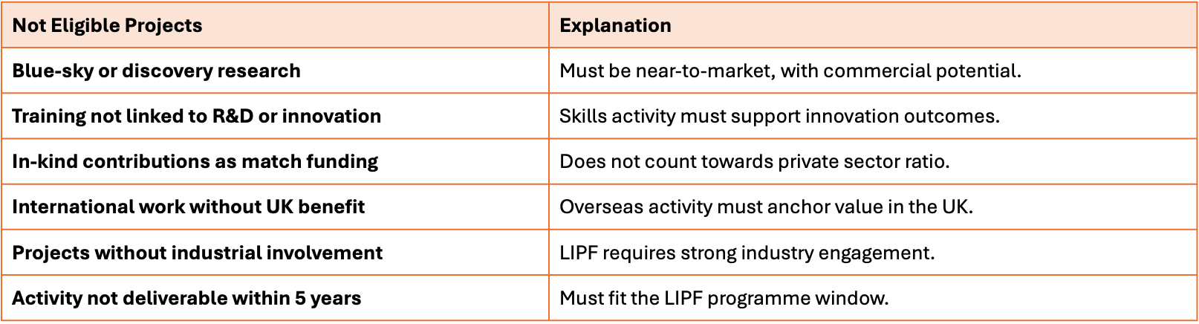

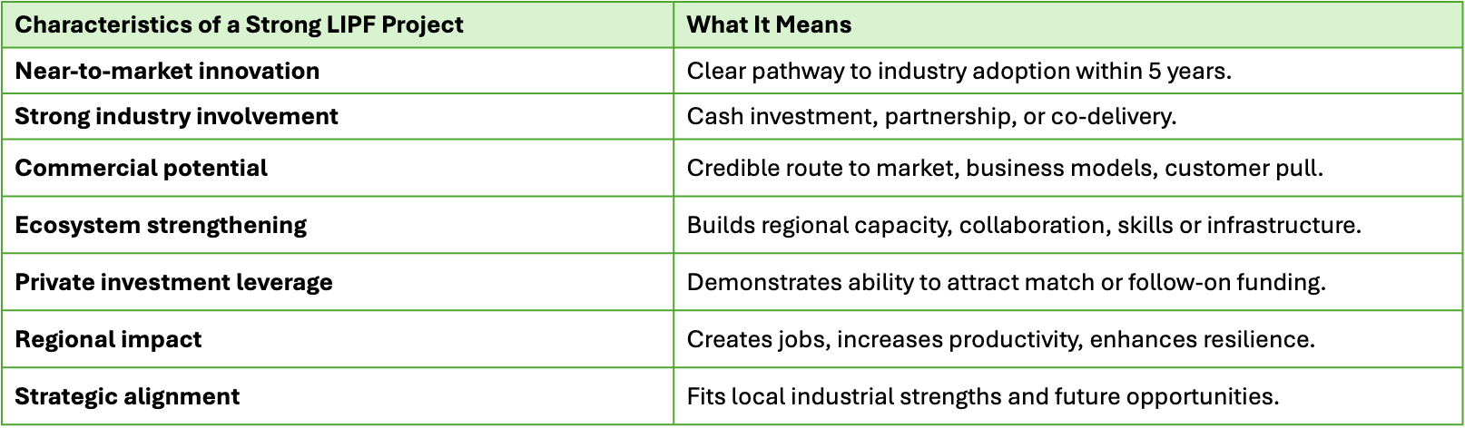

Website References
1. UK Industrial Strategy (2025) - The UK’s Modern Industrial Strategy
https://www.gov.uk/government/collections/the-uks-modern-industrial-strategy-2025
2. South West Wales Regional Economic Delivery Plan (REDP) https://democracy.npt.gov.uk/documents/s77664/REDP%20Appendix%20A%20Regional%20Economic%20Delivery%20Plan%20Final.pdf
3. UK Critical Minerals Strategy
https://www.gov.uk/government/publications/uk-critical-minerals-strategy

